Is the number of global natural disasters increasing?

Gianluca Alimontiª and Luigi Mariani^{b}

ªINFN & Università degli Studi di Milano, Department of Physics, Milano, Italy; ^{b}Department of Civil, Environmental, Architectural Engineering and Mathematics (DICATAM), Università degli Studi di Brescia, Brescia, Italy

ABSTRACT

We analyze temporal trends in the number of natural disasters reported since 1900 in the Emergency Events Database (EM-DAT) from the Center for Research on the Epidemiology of Disasters (CRED). Visual inspection suggests three distinct phases: first, a linear upward trend to around mid-century followed by rapid growth to the turn of the new century, and thereafter a decreasing trend to 2022. These observations are supported by piecewise regression analyses that identify three breakpoints (1922, 1975, 2002), with the most recent subperiod 2002–2022 characterized by a significant decline in number of events. A similar pattern over time is exhibited by contemporaneous number of geophysical disasters – volcanoes, earthquakes, dry landslides – which, by their nature, are not significantly influenced by climate or anthropogenic factors. We conclude that the patterns observed are largely attributable to progressively better reporting of natural disaster events, with the EM-DAT dataset now regarded as relatively complete since ∼2000. The above result sits in marked contradiction to earlier analyses by two UN bodies (FAO and UNDRR), which predicts an increasing number of natural disasters and impacts in concert with global warming. Our analyses strongly refute this assertion as well as extrapolations published by UNDRR based on this claim.

Introduction

Natural disasters are a constant threat to human populations, as shown by the myths of the flood present in cultures of various continents and reported in important poems of ancient times (e.g. Gilgamesh and the Bible). In the nineteenth century, with the discovery of the ice age by the Swiss geomorphologist Louis Agassiz (1837), there was a widespread fear of the destructive effects of a new glaciation, as testified by GiosuéCarducci, the first Italian poet to receive the Nobel prize, who in one of his most famous compositions ‘Su Monte Mario’, closed with an apocalyptic vision of the Earth with human life disappearing from the planet because of a new glaciation (Carducci, 1893).

The fear of global warming leading to an increase in natural disasters of meteorological origin (drought, extreme rain events, heat waves, landslides, tropical cyclones, tornadoes, etc.) with disruptive effects on human civilization, has recently taken hold. This stimulated the birth of datasets capable of collecting disastrous past events. For example, a dataset exists of the earthquakes that occurred in the distant past in Italy (INGV, n.d.) as well as a dataset of flood events and landslides (CNR, n.d.). International datasets have also been created that aggregate data related to natural disasters. One of these is EM-DAT, which was developed in 1988 by the Center for Research on the Epidemiology of Disasters (CRED [CRED, n.d.]) of the Catholic University of Louvain with the aim of rationalizing decision making to ensure disaster preparedness, while also providing an objective base for vulnerability assessment and priority setting purposes.

Considering all natural disasters present in EM-DAT from 1900 to 2022, as shown in Figure 1, a very small number of events can be observed until the middle of the last century, when a sudden growth begins towards the end of the twentieth century. This trend is very curious and we will here try to explain this pattern of behavior: is it possible that natural disasters ‘started’ around the middle of the twentieth century and this was followed by an apparent dramatic growth until the end of the century? This hypothesis, among other things, would be fully ‘consistent’ with the growth of the global temperature of our planet.

However, in previous reports, CRED often warned about an exclusively climatological interpretation of the events increase observed until the end of the twentieth century: Guha-Sapir et al. (2004) wrote that their time series (Figure 1 with data up to 2003) might lead one to believe that disasters occur more frequently today than in the beginning of the century. However, reaching such a conclusion based only on this graph would be incorrect. In fact, what the figure is really showing is the evolution of the registration of natural disaster events over time.

Again in 2008, CRED wrote (Scheuren, 2008):

Indeed, justifying the upward trend in hydro-meteorological disaster occurrence and impacts essentially through climate change would be misleading. ... one major contributor to the increase in disasters occurrence over the last decades is the constantly improving diffusion and accuracy of disaster related information.
These considerations have also been repeated in recent times when a 2015 CRED report (CRED, 2015)

mentioned:

The volume and quality of data about natural disasters increased enormously after 1960 when the US’s OFDA (Office of U.S. Foreign Disaster Assistance) actively began to collect information about these events. The arrival of CRED in 1973 further improved data recording while the development of global telecommunications and the media, plus increased humanitarian funding and reinforced international cooperation also contributed to better reporting of disasters. Thus part of the apparent increase in the frequency of disasters in the past half-century is, no doubt, due to improved recording.

The purpose of this analysis has been to evaluate the historical trend of the number of global natural disasters. The data source and the statistical analysis methods are first described in the next section, followed by a discussion of the results and the concluding comments.

To further clarify the focus of this paper, we would like to underline that it is not our intention to discuss here whether these disasters are related to and/or possibly originated from climate change. For an analysis of the trend of extreme events, please refer to other publications that deal with these issues at a global level (Alimonti et al., 2022; IPCC, 2012; IPCC, 2021) or which are more focused on specific events or territories (Coates et al., 2014; Klotzbach, 2006; Klotzbach et al., 2018).

As a final comment, the purpose of this paper is not to understand what complementary information is missing on a given collected disaster dataset or how such missing information should be handled to ensure that global disaster data can be trusted: for this specific purpose, the reader can refer to the dedicated literature (Jones et al., 2022).
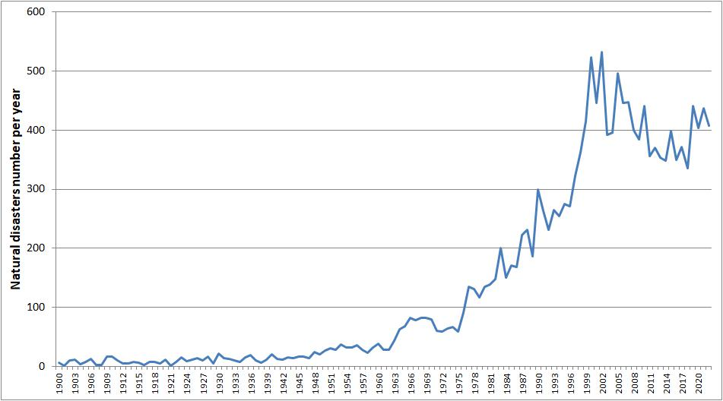

Figure 1. Natural disasters 1900–2022, extracted from the CRED dataset in May 2023.

Data and methods

The international disaster database used in this work is EM-DAT (Emergency Events Data- base [EMDAT]), created by CRED in 1988 with the initial support of the World Health Organization and the Belgian Government. The main objective of the database is to support humanitarian actions at national and international levels.
This analysis only refers to EM-DAT data, as it is the only publicly available global dis- aster database with almost 26,000 events that occurred from 1900 to the present day, and it is widely cited (Jones et al., 2022). For a systematic review of disaster databases, the reader can refer to other publications (Mazhin et al., 2021).

At least one of the following criteria must be fulfilled before a new event can be added to the database:

- 10 or more deaths.

- 100 or more people affected/injured/homeless.

- declaration of a state of emergency and/or an appeal for international assistance.

The database is compiled from various sources, including UN, governmental and non- governmental agencies, insurance companies, research institutes and press agencies: a disaster will only be entered into EM-DAT if at least two sources report the occurrence of a disaster in terms of deaths and/or affected people.
Two main groups of disasters are distinguished in EM-DAT: natural disasters and technological disasters. This

paper deals only with natural disasters and in EM-DAT this category is divided into 6 sub-groups: Biological, Geophysical, Climatological, Hydrological, Meteorological and Extra – terrestrial disasters.
Several types of information are recorded on an event basis: human impact (deaths, missing people, injured people ...), geographical and temporal data, economic and infra- structural data, physical characteristics and origin of the disaster (earthquake, flood, epi- demic, storm, chemical spill ... .). Such events are divided into two main categories, that is, natural and technological disasters. This work is focused on the former.

The time series were analyzed by means of a piecewise regression method where the response variable is split into two or more subperiods, and a line segment is fitted to each subperiod, with the constraint that the regression function must be continuous. Each line is connected to the other at an unknown value, called ‘breakpoint’. A piecewise regression is suitable when the behavior of the response variable shows abrupt changes to the explanatory variable and, in many cases, it offers a better fit than a simple linear regression model.

The piecewise regression method adopted in this work was proposed by Tome and Miranda (2004 and 2005) for the analysis of climate time series. It is a simple, non- linear approach that mimics the subjective analysis of a time series diagram that may be performed with a pen on a piece of paper, but it uses an objective numerical method that minimizes the mean square error of the fit. The method consists of fitting the data with a set of continuous line segments, where the number of segments, the location of the breakpoints between segments and the slopes of the different segments are optimized simultaneously. The minimum trend change at the breakpoints and the minimum interval between two consecutive breakpoints are free parameters; this interval acts as a low-pass filter and is useful to avoid the effects of inter-annual variability.

The Mann-Kendall Trend Test of the MannKendall function from the Kendall library of R-Cran [RCran] is used to determine whether or not a trend exists in time series data. This is a non-parametric test, which means no underlying assumption is made about the normality of the data. The hypotheses for the test are:

- H0 (null hypothesis): there is no trend present in the data.
- HA (alternative hypothesis): a trend is present in the data (it could be a positive or negative trend).

If the test p-value is lower than the standard significance level (common choices are 0.10, 0.05, and 0.01), there is statistically significant evidence that a trend is present in the time series data.

Results

The analysis was initially conducted on the entire dataset pertaining all natural disasters that had occurred throughout the world since 1900. The analysis next focused on data starting from 1970, the period where the main breakpoint, suggested by the CRED researchers to coincide with the beginning of the reporting maturity, was identified.

Two free parameters provided in the Tome-Miranda fit algorithm were used to optimize the analysis: the minimum interval between two consecutive breakpoints ‘M’, set equal to 15 years for the 1900–2022 analysis and equal to 10 and 15 years for the 1970–2022 analysis, and the minimum trend change at breakpoints ‘C’, set equal to 10, which is the minimum percentage of relative change between two consecutive slopes, and is used to identify only significant trend changes.

Figure 2 shows the results of the entire period and of the 1970–2022 period (M = 15 and C=10); these results were obtained from two independent analyses and the image starting from 1970 is not just a zoom of the final time interval of the image starting from 1900. An analysis was also performed on data starting from 1970, with M = 10, to ensure no strong bias was inserted into such a short time span and the result does not change.

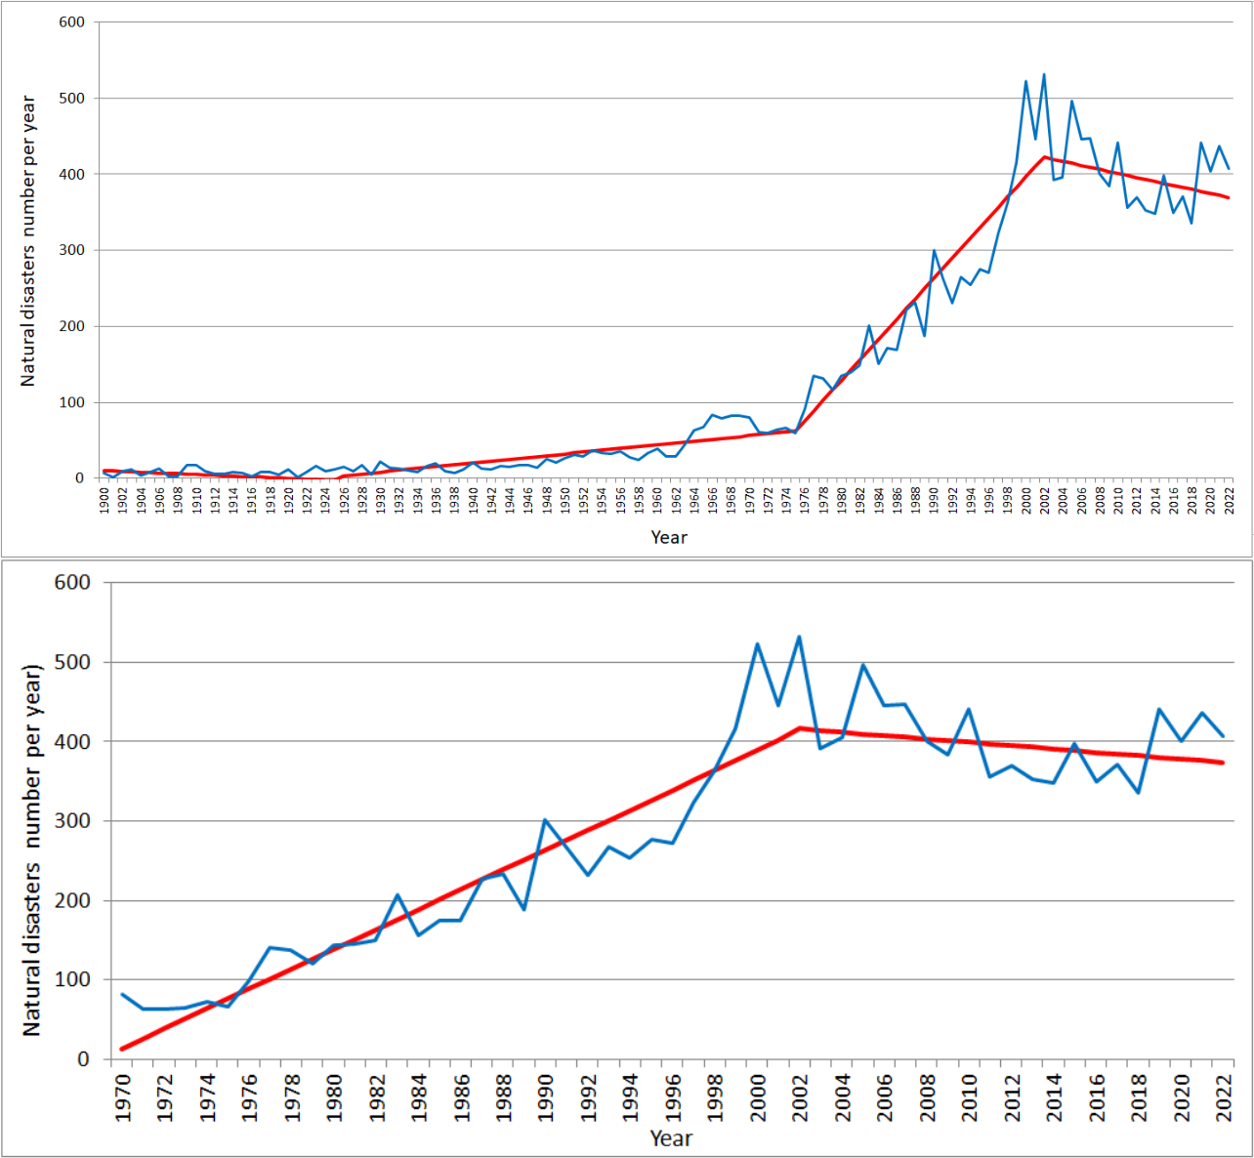

Figure 2. Natural disasters since 1900 (a) and 1970 (b). The piecewise fit with parameters M = 15 and C = 10 is reported in red.

The analysis shows that after a period of substantial stability in the number of natural disasters, an important growth is observed around the mid-1970s, identifiable with the sensitive improvement in the disaster reporting. This growth ends at around the beginning of the twenty-first century, when the reporting effectiveness can be considered reliable as stated in several CRED reports (Guha-Sapir et al., 2004; Scheuren et al., 2008; CRED, 2015).

It should also be noted that since the reporting effectiveness has been stable, since the turn of the century, the total number of natural disasters recorded in EM-DAT is slightly decreasing.
To further support the importance of reporting effectiveness in the trend of events recorded in the dataset, a similar analysis was conducted on the number of geophysical disasters originated by earthquakes, volcanic activity or dry mass movements which are supposed not modified to a great extent by human activities or by the global warming observed in the twentieth century: an eventual growth in geophysical disasters could therefore only be explained by a better event reporting.

Figure 3 shows the results from the analysis of geophysical disasters for the entire period and for the 1970–2022 period (M = 15 and C = 10). As for natural disasters, these two analysis are independent; moreover, a test was performed on data starting from 1970 with M = 10 to ensure no strong bias was inserted into such a short time span and the result does not change.
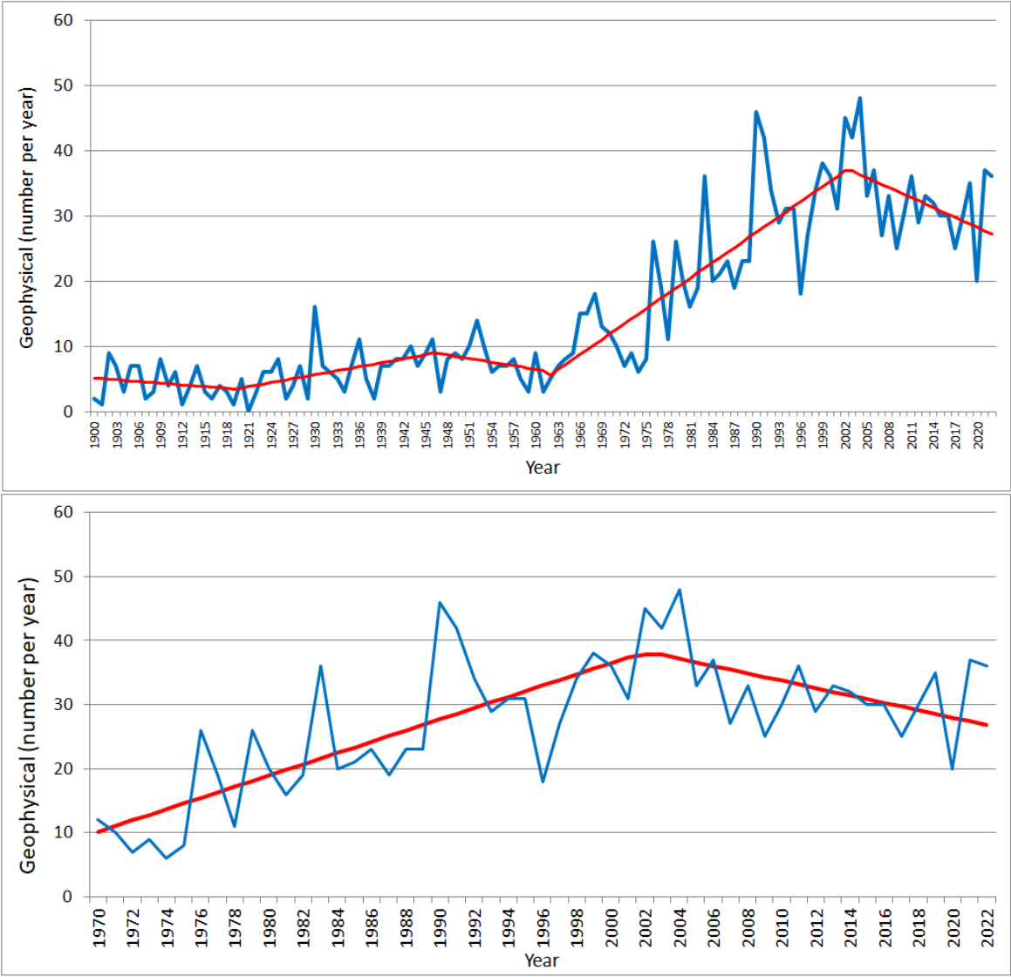

Figure 3. Geophysical disasters since 1900 (a) and 1970 (b). The piecewise fit with parameters M = 15 and C = 10 is reported in red.

The analysis of geophysical disasters led to results very similar to those obtained for all the natural disasters: after an initial period of stability, there was a growth in events, caused by the reporting improvement, which stopped in the first years of the twenty- first century, with the reporting stability. It should be noted that the breakpoint at the beginning of the twenty-first century is stable among the analyses shown in Figure 3, overlaps with the breakpoint identified by the analysis on all natural disasters and coincides with the cautious assessments expressed in several CRED reports (Guha-Sapir et al., 2004; Scheuren et al., 2008; CRED, 2015).

These considerations lead to the conclusion that the recorded events growth is an artefact originated by better reporting; the real trend of natural disasters can be considered stable, if not even slightly decreasing, since reporting reached maturity, that is since the beginning of the twenty-first century. Similar conclusions were reached in a very detailed study performed on a limited geographical area: ‘Rather than suggesting a dramatic increase in disasters in the last few decades, this suggests that EM-DAT’s scarcity of records for Singapore pre-1986 is reflected across the database as well’ (Lin et al., 2021).

Deaths caused by natural disasters since 1900 are shown in Figure 4 as accessory information: the decrease over the years is evident and is certainly not due to disasters decrease, but perhaps to a better prevention and defense capacity.
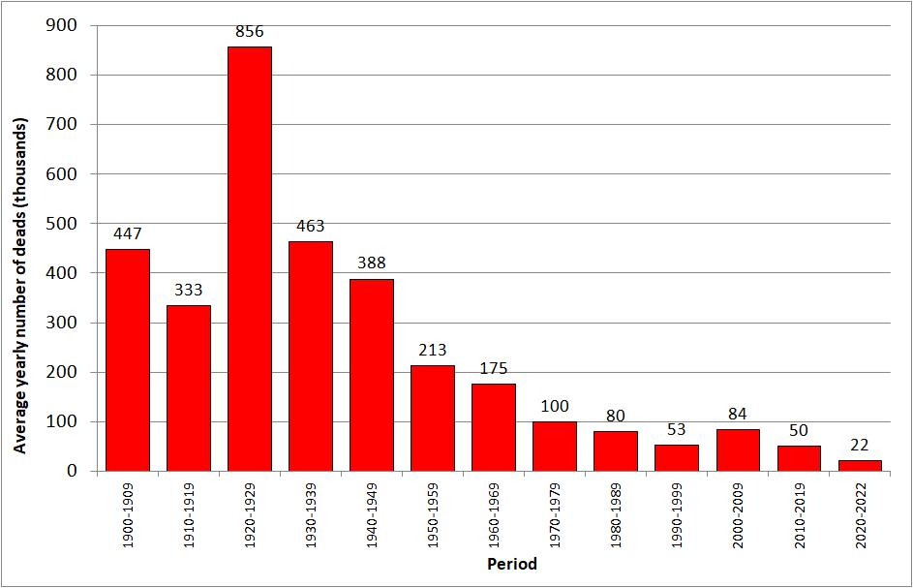

Figure 4. Average yearly deaths caused by natural disasters grouped by decade (the last bar is a three-year average).

As a final comment, we observe that the requirements to enter an event into EM-DAT represent a low threshold for natural disasters, originating a possible reporting bias that should become less important for a growing number of victims. According to Wirtz (2012), the reporting bias can be ruled out for natural catastrophes that cause at least 2000 deaths as it is very unlikely that events on such a major human scale would not have been reported in great detail. A Mann Kendall statistical analysis [RCran] was applied to classes of disasters with growing death thresholds, from 200 to 5000. Table 1 shows the absence of a trend for death classes > = 2000, while a significant trend is detected for lower thresholds, as can be seen in Figure 5. This could be considered further evidence that the number of events increase entered into EM-DAT is likely due to better reporting, which only affected those classes that gathered disasters that caused a low number of deaths. Nevertheless, it should be underlined that there are also external factors that can influence the number of these ‘high threshold’ events: although the number of people exposed to risks has been growing over time, prevention and protection systems have become more and more effective: the same frequency and intensity of extreme events may thus have different impacts, as suggested in Figure 4, and an analysis based on human or economic damages may therefore lead to incorrect conclusions about climatic events.
Deaths | Disaster type | tau | 2-sided pvalue
>=200 | Meteorological-climatological-hydrological | 0.627 | < 2.22e-16***
>=200 | Other Natural disasters | 0.376 | < 2.22e-16***
>=500 | Meteorological-climatological-hydrological | 0.468 | < 2.22e-16***
>=500 | Other Natural disasters | 0.234 | 0.00033295***
>=1000 | Meteorological-climatological-hydrological | 0.253 | 0.00015521***
>=1000 | Other Natural disasters | 0.117 | 0.078347*
>=2000 | Meteorological-climatological-hydrological | 0.0601 | 0.38806
>=2000 | Other Natural disasters | 0.0686 | 0.31672
>=5000 | Meteorological-climatological-hydrological | -0.0292 | 0.68316
>=5000 | Other Natural disasters | -0.0837 | 0.23864


*** = trend significance > 99.9%; ***=trend significance > 95%; *=trend significance > 90%;

Table 1. Mann Kendall test is applied to classes that gather disasters by growing the deaths threshold (from 200 to 5000).
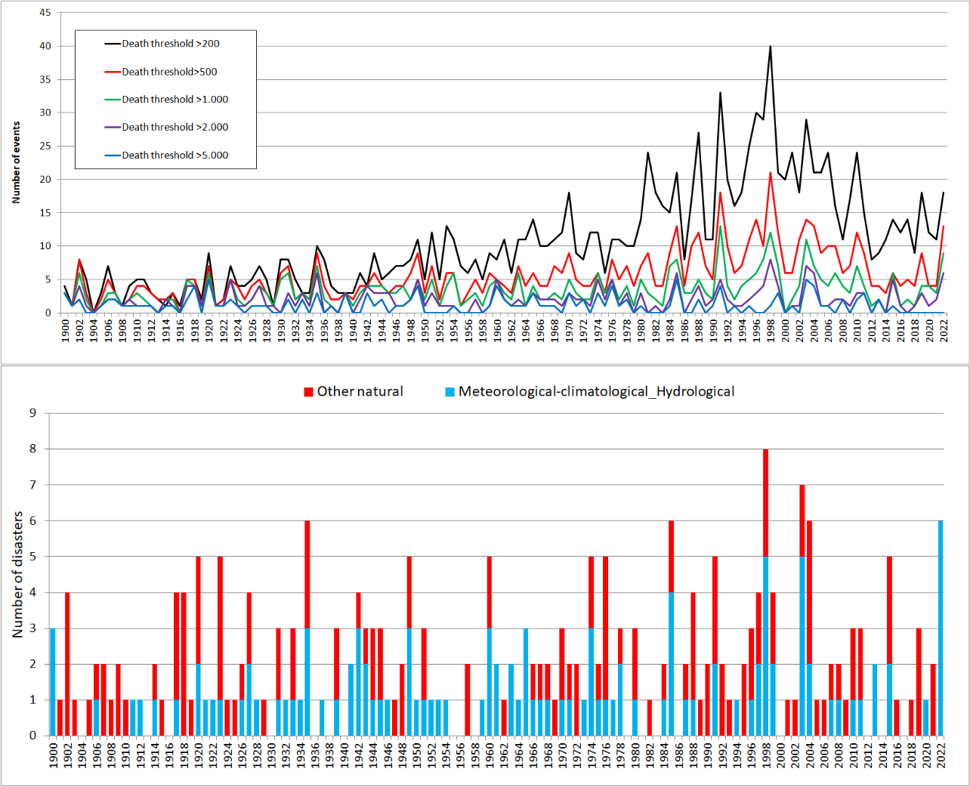

Figure 5. Number of disasters with growing death thresholds (top) and more than 2000 (bottom), where the Mann Kendall p-value shows no significant trend for either Meteo-Climatic-Hydrological or other Natural disasters.
Discussion

The claim that the increase in disasters registered in EM-DAT in the final part of the twentieth century is mostly, if not completely, caused by better reporting and not by a real events increase, is supported by three independent lines of evidence: (a) several CRED reports (Guha-Sapir et al., 2004; Scheuren et al., 2008; CRED, 2015); (b) best fit analysis that found an important breakpoint and even a change in the trend sign of natural dis-asters at the beginning of the 21th century, in agreement with what is written and justified in point a; (c) the same trend change and breakpoint for geophysical disasters that have very little, if anything, to do with human activities or global warming.

Nevertheless, the claim that natural disasters are dramatically increasing mostly due to global warming is present in three leading reports based on the same EM-DAT database.
The first report (UNDRR, 2020) is from the UN Office for Disaster Risk Reduction (UNDRR); this report only deals with geophysical, hydrological, meteorological, and climatological disasters (GHMC disasters), clearly focusing on possible increases caused by global warming. The report makes a comparison between the number of GHMC disasters in the last 20 years, 2000–2019, with the disasters that happened in the previous 20 years, 1980–1999, and at the beginning of the report, it stated ‘this report focuses primarily on the staggering rise in climate-related disasters over the last twenty years’.

GHMC disasters that have occurred since 1900 are presented in Figure 6 and the same data are shown in the UNDRR 2020 report (UNDRR, 2020), albeit only starting from the year 2000, and they differ slightly from ours because of the different extraction time from EM-DAT. It is clear that all the considerations expressed in this paper also apply to GHMC events: data do not support the attribution of the increase observed until the end of the last century to climate change. Moreover, Figure 6 shows that GHMC disasters are constant, if not decreasing, starting from the beginning of this century.
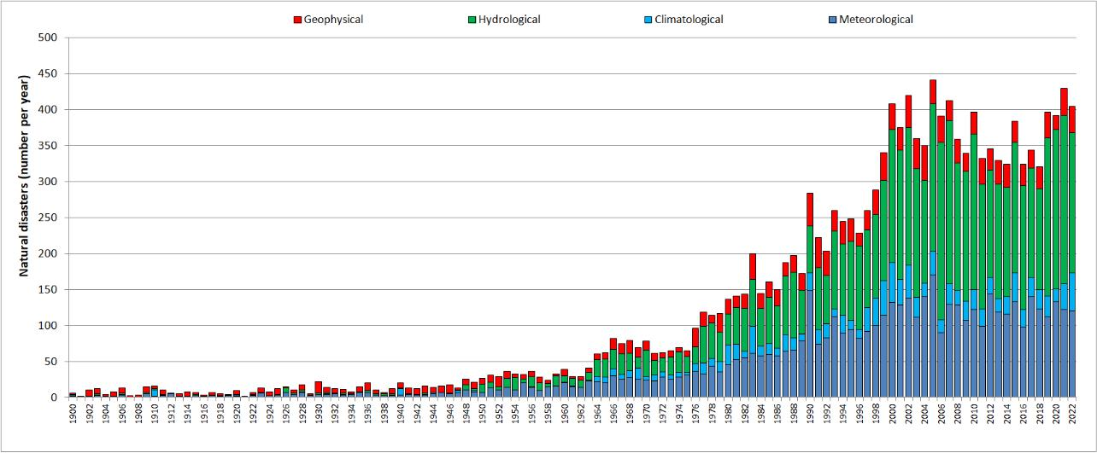

Figure 6. Stacked bar chart of the GHMC disasters since 1900

UNDRR report authors are well aware of the reporting limitations as it can be read ‘While better recording and reporting may partly explain some of the increase in events, much of it is due to a significant rise in the number of climate-related disasters’, but somehow they consider this a minor problem, despite the repeated CRED calls for prudence in interpreting such data.
Another report (FAO, 2021) dealing with all natural disasters and based on the same EM-DAT database, has been published by the Food and Agriculture Organization (FAO). Data are the same as those shown in Figure 1, and the reported considerations are:

Available data shows that increased disaster occurrence is indeed the new normal. While, a quick short-run comparison with the preceding decade shows that there were relatively fewer disaster peak years in the 2010s, the overall level of occurrence

remains at an all- time high. With the new millennium, disasters took a drastic leap in frequency and have continued to occur at a consistently high rate over the past 20 years.
According to this report, such an increased disaster occurrence has had a dramatic impact on agriculture:

At no other point in history has agriculture been faced with such an array of familiar and unfamiliar risks, interacting in a hyperconnected world and a precipitously changing landscape. The growing frequency and intensity of disasters, along with the systemic nature of risk, are jeopardizing our entire food system.
The reasons for the apparent increase in the last part of the previous century have already been discussed. As further evidence, the time series of global average yields (t/ha) for maize, rice, soybean, and wheat¹, and for the average of these four crops, as taken from the FAO database (FAO, n.d.) are reported in Figure 7 for the 1961– 2020 period: very robust positive linear trends, equal to 3.3%, 2.4%, 2.6% and 3.8% per year respectively, have been obtained for the four above-mentioned crops. Moreover, the linear trend for the average yield of the four crops was subtracted from data obtaining the residuals shown in Figure 8: there is no trace of an increasing trend in production variability caused, for example, by an increase in extreme meteorological or meteorologically driven events (heat waves, cold outbreaks, droughts, floods ...).

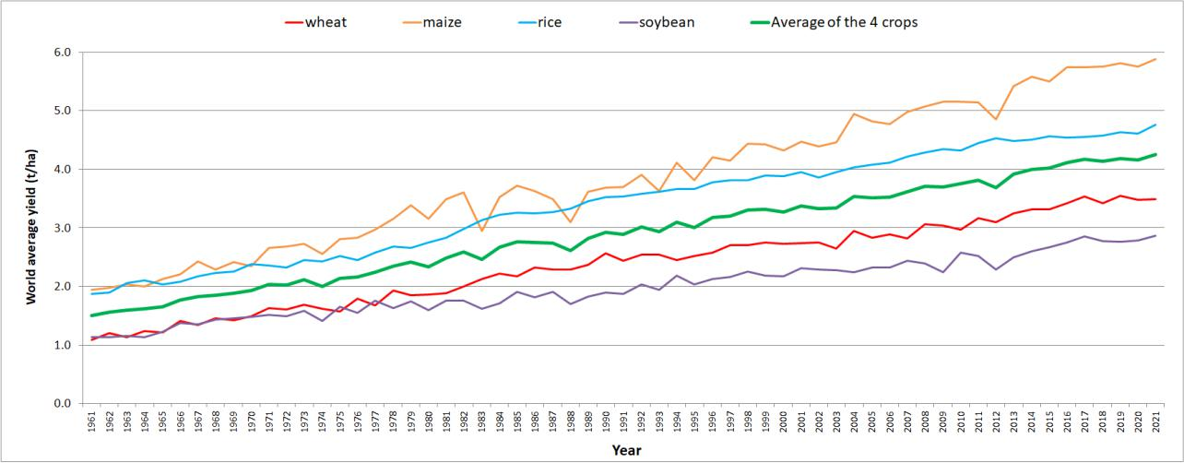

Figure 7. The 1961–2021 time series of the global average yields (t/ha) for maize, rice, soybean, and wheat, and for the average of the four crops.

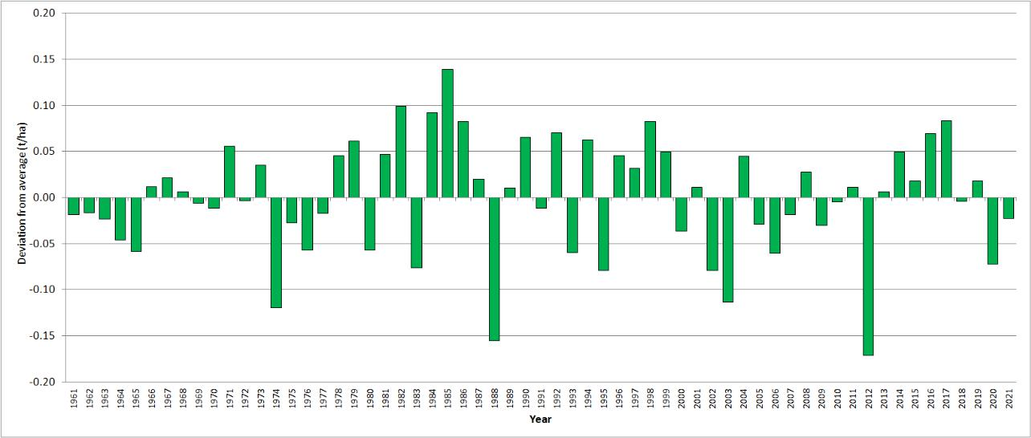

Figure 8. The 1961–2021 residuals (t/ha) for the average yield of the four crops (the green line in Figure 7).

In order to support the apparent increase in climate natural disasters, it can oddly be read in the FAO report:

While the average rate of geophysical disasters, such as earthquakes, landslides and mass movements, remained fairly stable over time (around 25 events per year in the 1980s and 1970s, up to 30–35 events annually in the 2000s and 2010s), other disaster types have radically increased since the 1970s.
As can be seen in Figure 3, and explained in the section dedicated to our results, EM- DAT data support exactly the opposite claim: geophysical disasters have undergone the same apparent increase as all natural disasters, this being further evidence that the increase seen at the end of the twentieth century is an artefact caused by better reporting.

The most recent report about natural disasters that we would like to discuss is again from UNDRR (UNDRR, 2022): the report deals with data on natural disasters from 1970. The focus is again on the increasing number of natural disasters originated, according to this report, by the increase in extreme climatic events due to climate change: The increasing number of reported medium – and large-scale disasters reflects a complex interaction of factors. Population growth and expanded settlements put more people and infrastructure in the path of existing hazards, and there is an increase in frequency and intensity of climatic hazards due to climate change.

This time, the (apparent) increase in natural disasters is partly justified by the population growth and expanded settlements, as suggested by CRED (CRED, 2015):

Of greater significance, however, is the rising number of people on the planet. Since disasters only occur when a natural hazard impacts on human beings, the total number of people in harm’s way increases the chances of a disaster occurring. The growth of cities and other high- density communities accentuates this risk.
Nevertheless, throughout the whole report, the focus is on the increase in frequency and intensity of hazards due to climate change and a comparison between the number of events in the last part of the XX century and the first 20 years of the XXI century is once more proposed: ‘Between 1970 and 2000, reports of medium – and large-scale disasters averaged around 90–100 per year, but between 2001 and 2020, the reported number of such events increased to 350–500 per year’.

We have already shown that disaster data do not support this reading, but the last UNDRR report (UNDRR,

2022) goes even further and shows a linear fit on data starting from 1970 and projecting a significant increase in disasters in the near future: ‘If current trends continue, the number of disasters per year globally may increase from around 400 in 2015 to 560 per year by 2030 – a projected increase of 40% during the lifetime of the Sendai Framework.’

The proposed linear fit is shown in Figure 9(a): again, data shown here may slightly differ from data considered in the UNDRR report (UNDRR, 2022), because of the different extraction time from EM-DAT, but the significance does not change.
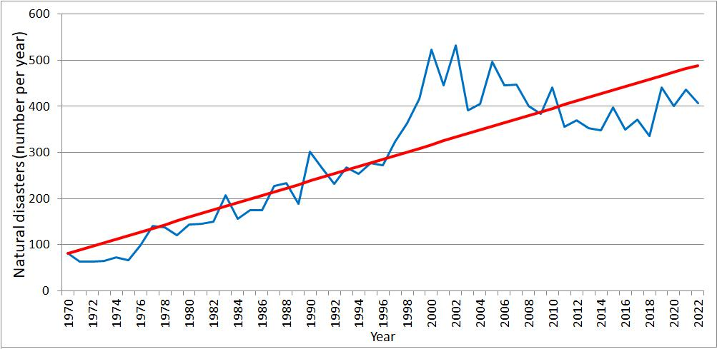
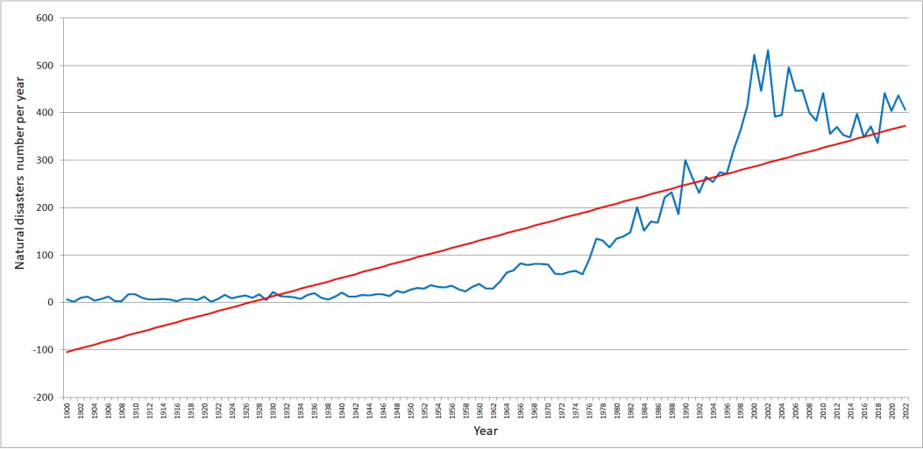

Figure 9. Natural disasters since 1970 (a) and 1900 (b). The linear fit is reported in red.

Few considerations about the proposed linear fit are needed:

- no reason is given why the fit starts in 1970: to correctly understand such data, the whole interval from 1900 onward should be considered. Looking at Figure 9(b), it is evident how inappropriate a linear fit would be for the whole dataset. In general, the choice of starting points in a time series can lead to quite different conclusions about trends in the data (McAn, 2017).

- according to several comments made by CRED (Guha-Sapir et al., 2004; Scheuren et al., 2008; CRED, 2015), it is clear that data from 1970 onward are not homogeneous and a linear fit is therefore not justified.
- even starting from 1970, it is obvious that a linear fit is not a good data interpolation. This conclusion can be confirmed by carrying out the regression between the linearly interpolated data from 1970 and the measured data from 2002 onward (when the break- point was found by the Tome-Miranda fit algorithm, as shown in Figure 2(b), whereby an interpolating linear fit is obtained with an R2 of 0.21 and an angular coefficient of −0.416, indicating an inverse correlation.

As a final comment, if the aim is to show a correlation between natural disasters and the increasing global average temperature, it should eventually be shown between temperature and extreme climate events, because several factors may play a role in originating and recording natural disasters, as suggested in different CRED reports (Guha-Sapir et al., 2004; Scheuren et al., 2008; CRED, 2015). Specific publications are available concerning the possible correlation between temperature and extreme climate events (Alimonti et al., 2022; IPCC, 2012; IPCC, 2021).

For similar reasons, many interacting variables make the causal link between economic losses and extreme events difficult to analyze: goods that can be damaged and people who can be affected, injured, or killed may change significantly over time; on the other hand, prevention and adaptation strategies can drastically mitigate the effects of natural events of the same magnitude. This specific issue has not been dealt with in this paper, but there are several publications that have shown no significant, or even decreasing, normalized economic loss trends caused by extreme meteorological events (Klotzbach et al., 2018; McAneney et al., 2019 Pielke & Landsea, 1998; Pielke & Landsea, 2008).

Finally, we highlight that one of the presuppositions of our analysis is that the number of geophysical disasters is not modified to a great extent by human activities or by the global warming observed in the twentieth century so their eventual growth could only be explained by better event reporting. Some possible exceptions to this statement are hereafter reported.

A relationship between weather or climate, and earthquakes has been suspected for over 2400 years. However, scientific evidence to support such a relationship has only been available since the 1980s. As faults in the Earth’s crust are generally regarded as critically stressed, small changes in stress and pore-fluid pressure brought about
by rainfall, snow, atmospheric pressure and temperature variations have all been proposed to modulate seismicity at both local and regional scales (Wilson et al., 2022). Although these studies are still at an early stage, the first results seem to point out a possible minor increase, in the order of 10–20%, of the number of major and moderate earthquakes in the last century (Masih, 2018; Panza et al., 2010).

Hydraulic fracturing, or fracking as it is commonly called, is a well stimulation technique that is used to enhance permeability in order to aid geological resource management, including the extraction of shale gas. The hydraulic fracturing process can induce seismicity which has often been reported to be an issue of public concern. Several studies have pointed out a close correlation between fracking and induced seismicity (Frohlich, 2012; Lei et al., 2017; López-Comino et al., 2018), but only minor earthquakes are generally originated in this way and it is very unlikely that they can give rise to disasters with the characteristics required to be registered in EM-DAT.

As far as volcanic activity is concerned, the loading and unloading of glaciers may change the surface pressure and stress relationships in the crust and upper mantle (Schmidt et al., 2013). These changes in surface loading exerted by large variations in glacier size are known to affect the rates of volcanic activity during glacial - interglacial transitions. Numerical models suggest that smaller changes in ice volume over shorter time scales may also influence mantle melt generation rates, with a consequent impact on volcanic activity. Researchers have recently found a time lag of about six centuries between climate forcing and changes in eruption frequency, and have concluded that the impact of the post Little Ice Age deglaciation on volcanic eruption frequency may not be discerned for hundreds of years (Swindles et al., 2017).

Dry mass movements recorded during geophysical disasters are considered apart from landslides that originated from snow or rainfall, and which are therefore not related to the weather. Overall, geophysical disasters have thus no or very little connection with human activities or climate change, and any frequency change should thus be considered to be very likely due to better reporting.

Conclusions

The EM-DAT dataset of natural disasters has been analyzed by means of the piece-wise method of Tome and Miranda, and it has been concluded that the trend is not homogeneous over the whole 1900–2022 series due to various factors, the main one being the growing reporting effectiveness. Therefore, before any trend analysis, the time series should be broken into sub-series: the most recent time interval, beginning in the first years of the twenty-first century, shows a decreasing trend whose degree of realism is strengthened by the fact that the time series in the new century can be considered complete, given the increased effectiveness of the monitoring and reporting activities of natural disasters.

Next, the statement that we are facing an increasing trend of natural disasters, as claimed in the three official reports by UNDRR and FAO (FAO, 2021; UNDRR, 2020; UNDRR, 2022) on the basis of the same EM-DAT dataset, has been checked: a linear trend on data starting from 1970 has been found in the most recent report by UNDRR (UNDRR, 2022), and this trend has been projected to continue in the future, thus forecasting a further increase in natural disasters of 40% during the lifetime of the Sendai Framework. Our conclusion is that the claims presented in the above mentioned reports are not supported by data.

In light of this deduction, the authors are concerned about the misrepresentation of the natural disaster trend because such claims have been uncritically broadcast by many different media and by FAO itself, thereby deforming the perception of the public on the risk of natural disasters. Let us consider that if the trend found by the linear fit proposed by UNDRR is projected, 560 natural disasters are foreseen by 2030 (UNDRR, 2022) and over 700 by 2050; the more realistic fit proposed in this work, would instead yield about 200 fewer disasters by 2030, and less than half by 2050.

Misinterpreting the trend of natural disasters is a very serious matter because exposes the world population to the risk of inconsistent policies at both a national and an inter- national level, thereby wasting resources or diverting them from the resolution of much more concrete problems.

The fact that mortality from extreme climatic or atmospheric events decreased by more than 90% in the last century, while the world population increased to a great extent, invites us to reflect on the causes of such a phenomenon. In our view, the lack of growth of natural disasters in the new millennium demonstrates the effectiveness of the civil protection policies introduced for the management of natural disasters (PPRR – Prevention, Preparedness, Response and Recovery [PPRR]) implemented in the last few decades.
Note

- These crops were chosen because they represent the four main world agricultural commodities and account for about 64% of global caloric consumption (Gray et al., 2014).
Acknowledgments

The authors thank the reviewers for their valuable suggestions that allowed a significant improve- ment of the manuscript.

Disclosure statement

No potential conflict of interest was reported by the authors.

Data availability statement

The data that support the findings of this study are available to the public on the links specified in the article.

References

Alimonti, G., Mariani, L., Prodi, F., & Ricci, R. A. (2022). A critical assessment of extreme events trends in times of global warming. The European Physical Journal Plus, 137(1), 1–20. https://doi.org/10. 1140/epjp/s13360-021-02243-9

Carducci, G. (1893). Su Monte Mario, Delle Odi Barbare, Libro II (in Italian), https://it.wikisource.org/ wiki/Odi_barbare/Delle_Odi_Barbare_Libro_II/Su_Monte_Mario

CNR. (n.d.). Catalogo degli eventi di frana e di inondazione che hanno prodotto danni alla popola- zione. https://www.cnr.it/it/banche-dati-istituti/banca-dati/869/catalogo-degli-eventi-di-frana- di-inondazione-che-hanno-prodotto-danni-alla-popolazione

Coates L., Haynes K., O’Brien J., McAneney J., Dimer de Oliveira F., (2014). Exploring 167 years of vul- nerability: An examination of extreme heat events in Australia 1844–2010. Environmental Science & Policy, 42, 33–44. https://doi.org/10.1016/j.envsci.2014.05.003.

CRED (n.d.). EM-DAT, The International Disaster Database, Inventorying hazards & disasters world- wide since 1988. https://www.cred.be

CRED. (2015). The human cost of natural disasters: A global perspective. http://www.cred.be/sites/ default/files/The_Human_Cost_of_Natural_Disasters_CRED.pdf.

FAO. (n.d.). FAOSTAT, Food and agriculture data. https://www.fao.org/faostat/en/#home.
FAO. (2021). The impact of disasters and crises on agriculture and food security, Rome. https://doi. org/10.4060/cb3673en

Frohlich, C. (2012). Two-year survey comparing earthquake activity and injection-well locations in the Barnett Shale, Texas. Proceedings of the National Academy of Sciences, 109(35), 13934–13938. https://doi.org/10.1073/pnas.1207728109

Gray, M., Frolking, S., Kort, E. A., Ray, D. K., Kucharik, C. J., Ramankutty, N., & Friedl, M. A. (2014). Direct human influence on atmospheric CO2 seasonality from increased cropland productivity. Nature, 515(7527), 398–401. https://doi.org/10.1038/nature13957

Guha-Sapir, D, Hargitt, D, & Hoyois, P. (2004). Thirty years of natural disasters 1974-2003: the numbers, Presses Universitaires de Louvain. https://www.emdat.be/thirty-years-natural-disasters-1974-2003-numbers

INGV (n.d.). I terremoti del passato nei cataloghi storici e nelle banche dati, preziose fonti di informazioni (in Italian), https://www.ingv.it/it/newsletter-ingv-n-8-ottobre-2021-anno-xv/i-terremoti-del-passato-nei-cataloghi-storici-e-nelle-banche-dati-preziose-fonti-di-informazioni
IPCC. (2012). Managing the risks of extreme events and disasters to advance climate change adaptation. In A special report of working groups I and II of the intergovernmental panel on climate change. Cambridge: Cambridge University Press. https://www.ipcc.ch/report/managing-the-risks-of-extreme-events-and-disasters-to-advance-climate-change-adaptation/.
IPCC. (2021). Weather and climate extreme events in a changing climate. In Climate change 2021: The physical science basis. Contribution of working group I to the sixth assessment report of the intergovernmental panel on climate change (pp. 1513– 1766). Cambridge: Cambridge University Press. https://doi.org/10.1017/9781009157896.013

Jones, R. L., Guha-Sapir, D., & Tubeuf, S. (2022). Human and economic impacts of natural disasters: can we trust the global data? Scientific Data, 9(1), 572. https://doi.org/10.1038/s41597-022-01667-x

Klotzbach, P., J., Bowen, S., G., Pielke R., Jr., Michael Bell, M. (2018). Continental landfall frequency and associated damage:

Observations and future risks. American Meteorological Society, 99. https://doi.org/10.1175/BAMS-D-17-0184.1

Klotzbach, P. J. (2006). Trends in global tropical cyclone activity over the past twenty years (1986-2005). Geophysical Research Letters, 33, L10805. https://doi.org/10.1029/2006GL025881

Lei, X., Huang, D., Su, J., Jiang, G., Wang, X., Wang, H., Guo, X., & Fu, H. (2017). Fault reactivation and earthquakes with magnitudes of up to Mw4.7 induced by shale-gas hydraulic fracturing in Sichuan Basin, China. Scientific Reports, 7, 1–12. https://doi.org/10.1038/s41598-017-08557-y

Lin, Y. C., Khan, F., Jenkins, S. F., & Lallemant, D. (2021). Filling the disaster data gap: Lessons from cataloging Singapore’s past disasters. International Journal of Disaster Risk Science, 12(2), 188–204. https://doi.org/10.1007/s13753-021-00331-z
López-Comino, J. A., Cesca, S., Jarosławski, J., Montcoudiol, N., Heimann, S., Dahm, T., Lasocki, S., Gunning, A., Capuano, P., & Ellsworth, W. L. (2018). Induced seismicity response of hydraulic frac- turing: results of a multidisciplinary monitoring at the Wysin site, Poland. Scientific Reports, 8, 1– 14. https://doi.org/10.1038/s41598-018-26970-9

Masih, A. (2018). IOP Conference Series: Earth and Environmental Science, 167, 012018. https://doi.org/ 10.1088/1755-1315/167/1/012018

Mazhin, S. A., Farrokhi, M., Noroozi, M., Roudini, J., Hosseini, S. A., Motlagh, M. E., et al. (2021). Worldwide disaster loss and damage databases: A systematic reviews. Journal of Education and Health Promotion, 10(329).

McAneney, J., Honert, R., & Yeo, S. (2017). Stationarity of major flood frequencies and heights on the Ba River, Fiji, over a 122-year record. International Journal of Climatology. https://doi.org/10.1002/ joc.4989
McAneney, J., Sandercock, B., Crompton, R., Mortlock, T., Musulin, R., Pielke, R., & Gissing, A. (2019). Normalized insurance losses from Australian natural disasters: 1966–2017. Environmental Hazards, 18(5), 414–433. https://doi.org/10.1080/17477891.2019.1609406

Panza, G. F., Peresan, A., & Zuccolo, E. (2010). Climatic modulation of seismicity in the Alpine- Himalayan mountain ranges. Terra Nova, 23(1), 19–25. https://doi.org/10.1111/j.1365-3121. 2010.00976.x

Pielke R., A., Jr., Gratz, J., Landsea, C., W., Collins, D., Saunders, M., A., & Rade Musulin R. (2008). Normalized hurricane damages in the United States:1900–2005. Natural Hazards Review, 9(1), 29–42. https://www.nhc.noaa.gov/pdf/NormalizedHurricane2008.pdf

Pielke, R. A., Jr., & Landsea, C. W. (1998). Normalized hurricane damage in the United States: 1925–95. Weather Forecast,
13(3), 621–631. doi:10.1175/1520-0434(1998)013<0621:NHDITU>2.0.CO;2

RCran. https://cran.r-project.org/web/packages/Kendall/Kendall.pdf.

Scheuren, J-M., Le Polain, O., Below, R., Guha-Sapir, D., & Ponserre, S. (2008). Annual disaster statistical review: Numbers and trends. https://www.cred.be/node/316
Schmidt, P., Lund, B., Hieronymus, C., Maclennan, J., Arnadóttir, T., & Pagli, C. (2013). Effects of present-day deglaciation in Iceland on mantle melt production rates. JGR: Solid Earth. https:// doi.org/10.1002/jgrb.50273.

Swindles, G. T., Watson, E. J., Savov, I. P., Lawson, I. T., Schmidt, A., Hooper, A., Cooper, C. L., Connor, C. B., Gloor, M., & Carrivick, J. L. (2017). Climatic control on Icelandic volcanic activity during the mid-Holocene. Geology, 46(1), 47–50. https://doi.org/10.1130/G39633.1

Tome, A. R., & Miranda, P. M. A. (2004). Piecewise linear fitting and trend changing points of climate parameters. Geophysical Research Letters, 31(2), 1–4. https://doi.org/10.1029/2003GL019100

Tome, A. R., & Miranda, P. M. A. (2005). Continuous partial trends and low-frequency oscillations of time series. Nonlinear Processes in Geophysics, 12(4), 451–460. https://doi.org/10.5194/npg-12-451-2005

UNDRR. (2020). Human cost of disasters 2000-2019. https://www.undrr.org/publication/human-cost-disasters-overview-last-20-years-2000-2019

UNDRR. (2022). Global assessment report on disaster risk reduction. https://www.undrr.org/gar2022-our-world-risk

Wilson, M. P., Foulger, G. R., Saville, C., Graham, S. P., & Julian, B. R. (2022). Earthquake weather and climate change: Should we stress about the forecast? The Geological Society of America. https:// doi.org/10.1130/2021.2553(15)

Wirtz, A., Kron, W., Löw, P., & Steuer, M. (2012). The need for data: Natural disasters and the challenges of database management. Natural Hazards, 70(1), 135–157. https://doi.org/10.1007/s11069-012-0312-4
Yaghmae, N., et al. Human cost of disasters 2000-2019 report – UN Office for Disaster Risk Reduction (UNDRR, 2020).
https://www.undrr.org/publication/human-cost-disasters-overview-last-20-years- 2000-2019.

