Alan Welch Harcrut Temps Analysis
30 June 2022

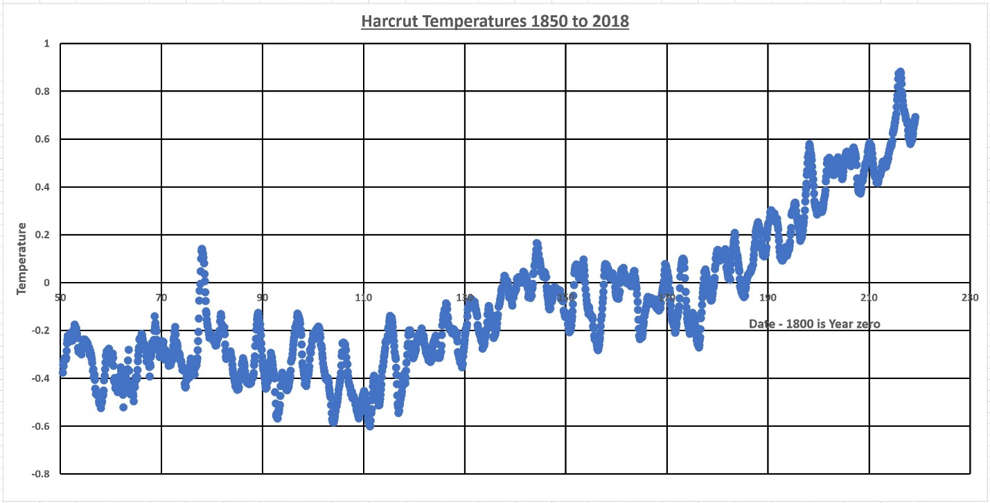
1 – Harcrut basic data

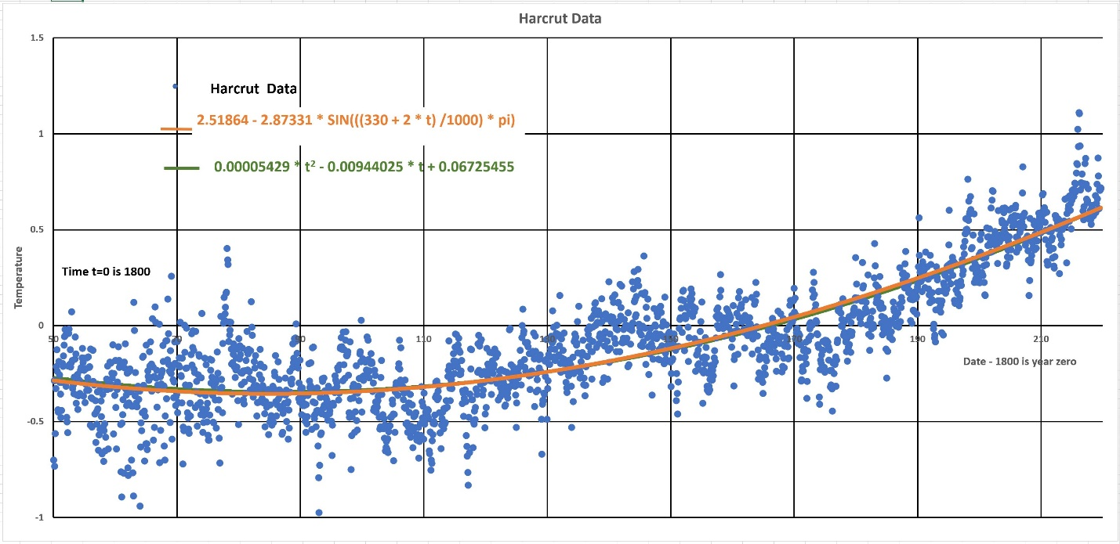
2 – Harcrut Data – 1850 to 2018 with best quadratic fit and a sinusoidal fit of a 1000 long term curve with an amplitude of +/- 2.87 degrees. The sinusoidal curve is just one of many but I feel a 1000 year period is a reasonable choice for starters.

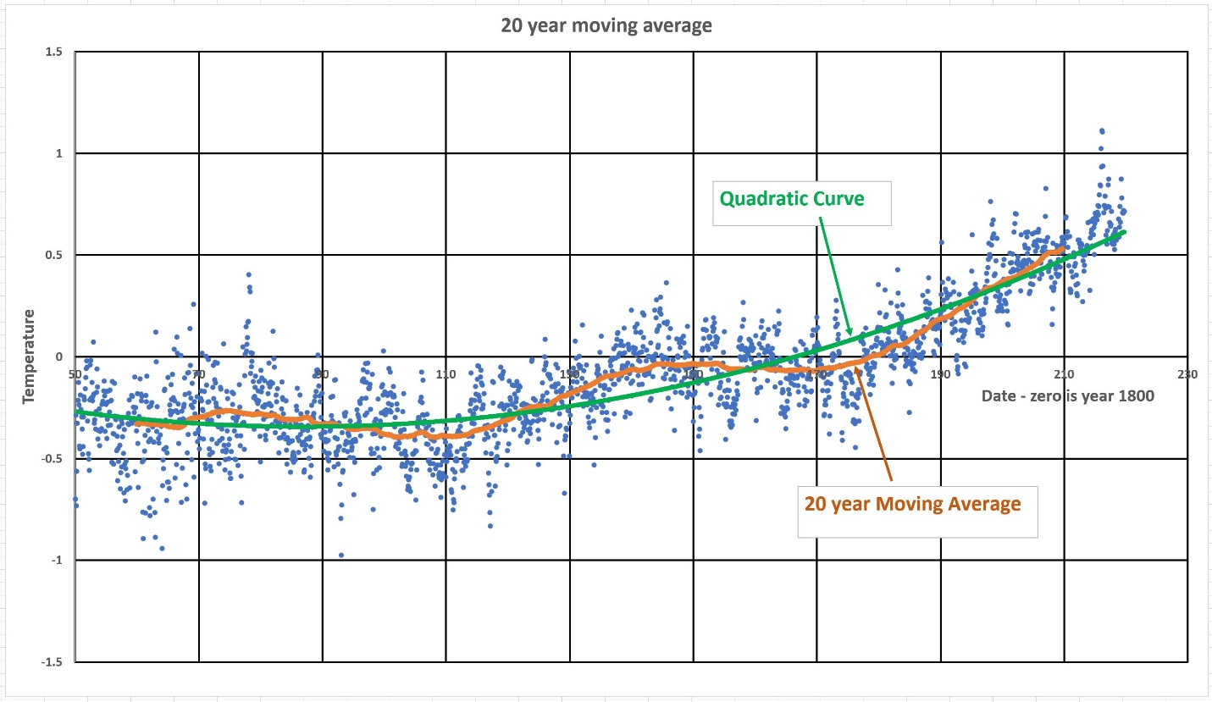
3 – 20 year moving average – indicate possible 65 year variation

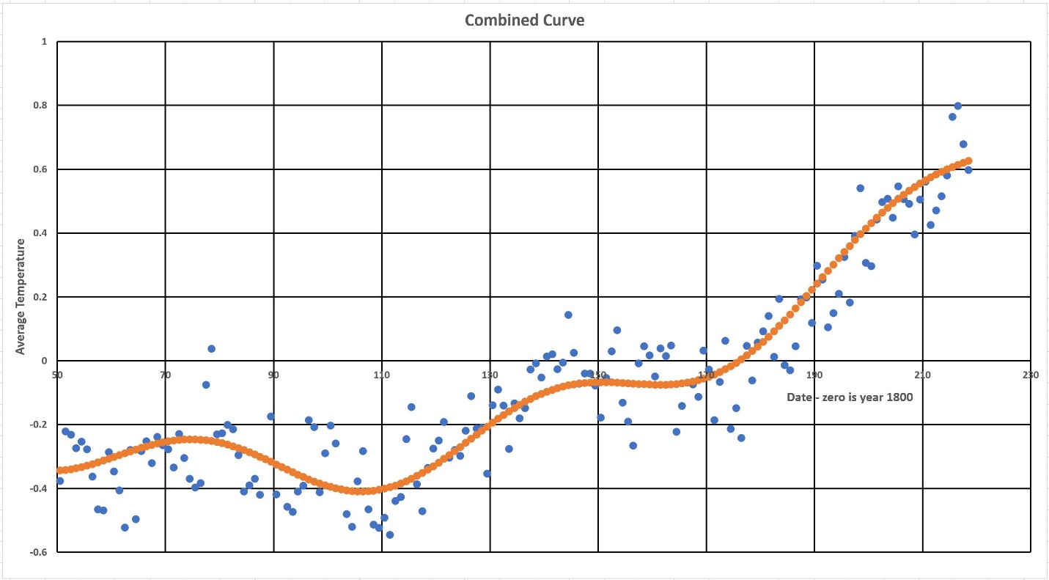
4 – Combined Curve -best fit quadratic plus sinusoidal curve with 65 year period and +/- 0.09 degree amplitude

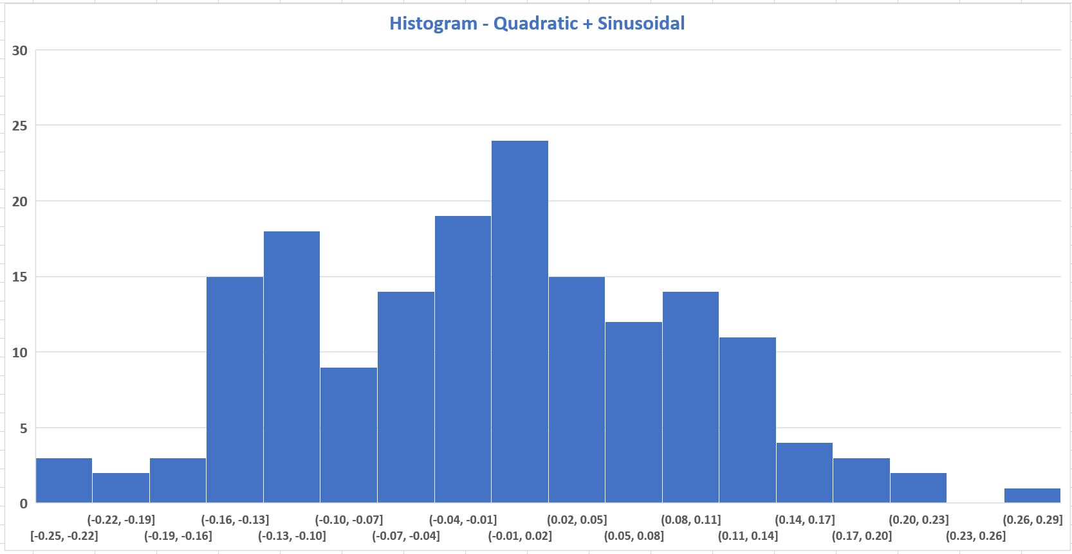
5 – Histogram – Histogram of differences between actual data and fitted combined curve. Standard Deviation 0.1024 degrees

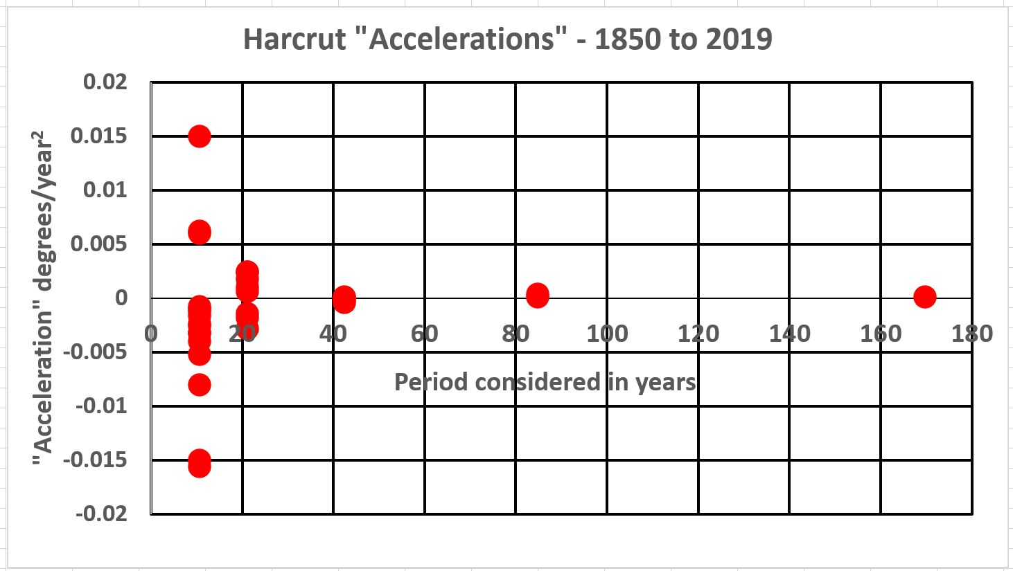
6 – Accelerations – over 5 different time periods down to 10.6 years with an amplitude of +/- 2.87 degrees. The sinusoidal curve is just one of many but I feel a 1000 year period is a reasonable choice for starters.

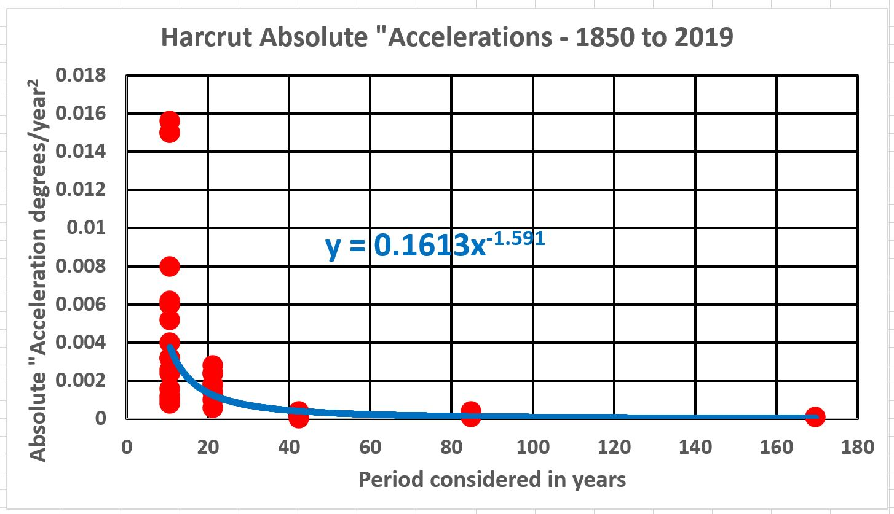
7 – Absolute accelerations – power term -1.591

