What you’ll need
- Four double-page sheets of newspaper
- Plenty of Scotch tape on a dispenser — preferably three-quarter-inch width but half an inch should be OK
- Polyester sewing thread — polyester embroidery thread is nearly as good, with no chance of breakage
- A pen or pencil
- A three-foot ruler or any handy straight edge that’s long enough
- Scissors
- A bamboo or metal skewer, no more than three millimeters in diameter

Start by making the sail

Image
Credit...Tony Cenicola/The New York Times
Step 1
Sharpen the crease down the middle of a double-page sheet of newspaper and then open it. With your pencil, make a dot about a finger-width from the top of the page.
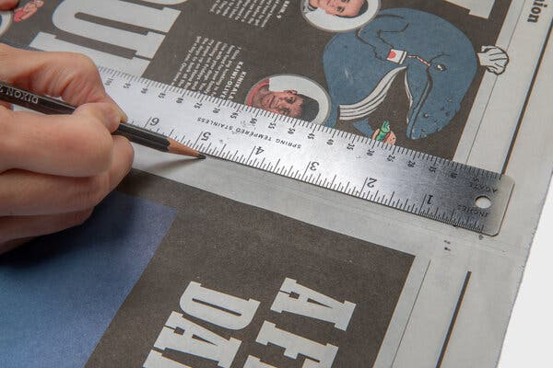
Image
Credit...Tony Cenicola/The New York Times
Step 2
Measure four and three-quarter inches straight down from the dot and mark the spot. From that spot, measure nine and a half inches out to each side, again marking the spots. Going back to the middle dot, measure 14 and a quarter inches down from it and mark the spot.
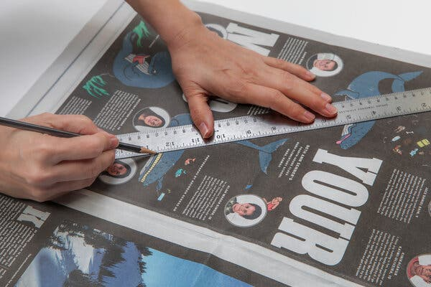
Image
Credit...Tony Cenicola/The New York Times
Step 3
Use a ruler to draw straight lines between the dots to create a diamond outline. Lay tape over the lines, centering the edges of the tape over the lines.

Image
Credit...Tony Cenicola/The New York Times
Step 4
Cut out the diamond shape with scissors. This will leave half the width of the tape all around the edges of the newspaper diamond. The tape produces a neat edge and helps avoid tearing while in flight.

Now make the spars (a fancy name for the sticks!)
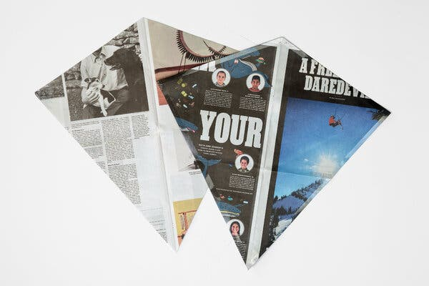
Image
Credit...Tony Cenicola/The New York Times
Step 5
Lay down the diamond-shaped sail over another sheet of newspaper and make a duplicate sail shape. No need to tape the edges as you’ll make this diamond into a spar.
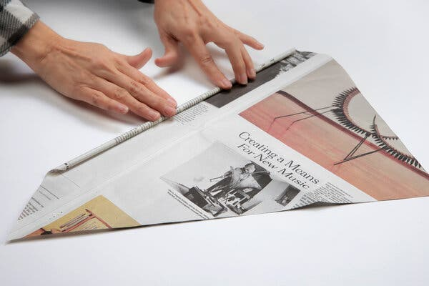
Image
Credit...Tony Cenicola/The New York Times
Step 6
Roll the newspaper around the skewer from one side to the other across the width of the kite. After a few turns, remove the skewer and continue rolling as tightly as possible. Once you have finished rolling, secure the free side point to the roll with a one-inch piece of tape, so the paper can’t unravel. This will be your vertical spar on the kite.

Image
Credit...Tony Cenicola/The New York Times
Step 7
On a new double-page sheet of newspaper mark out a square, 13⅜ inches by 13⅜ inches, using a pen and ruler. Cut out the square and roll the newspaper diagonally from corner to corner around the skewer as you did in Step 6. The resulting spar should be about 19 inches long and will be your horizontal spar on the kite. Add tape to secure.

Next, build the tail

Image
Credit...Tony Cenicola/The New York Times
Step 8
Using another sheet of newspaper, rule lines parallel horizontally across it one-and-a-quarter inches apart. Place tape along the full length of the lines. This helps strengthen the tail when the kite is in flight.
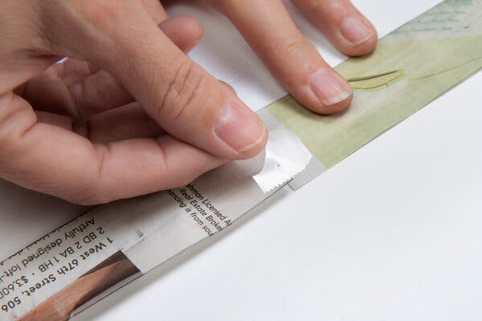
Image
Credit...Tony Cenicola/The New York Times
Step 9
Cut along the lines with scissors and join the resulting strips end-to-end with tape on both sides (you should have at least 16 feet of tail strip).

Assemble the kite
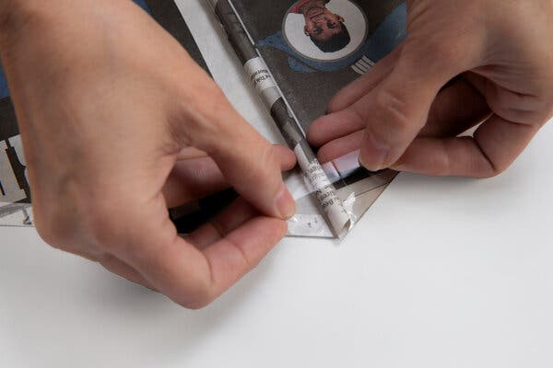
Image
Credit...Tony Cenicola/The New York Times
Step 10
One of the ends of the vertical spar will be heavier. If you put the middle of the spar across an outstretched finger, you can feel it easily. Place the heavy end over the top point of the sail and the other end over the bottom point of the sail. Secure the ends to the sail with short strips of tape.
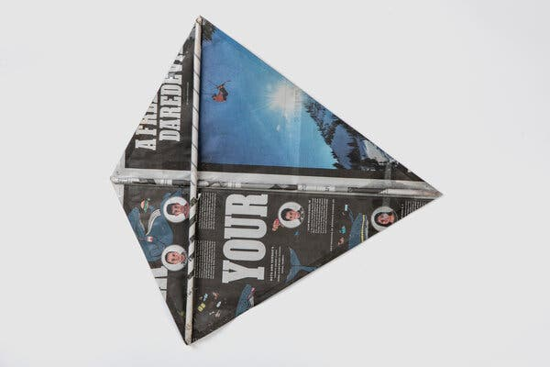
Image
Credit...Tony Cenicola/The New York Times
Step 11
Place the horizontal spar across the sail so one end aligns with a side point of the sail. Secure the spar tip to the point with a short strip of tape. Now bring the other end down and align it with the other side of the sail. Secure with tape as before.
Be careful not to crush the spars where they cross.
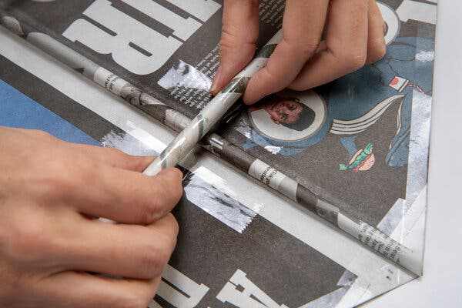
Image
Credit...Tony Cenicola/The New York Times
Step 12
Place two four-inch strips of tape vertically across the horizontal spar half an inch on either side of the vertical spar. Tape to the sail, being careful not to crush the tubes.
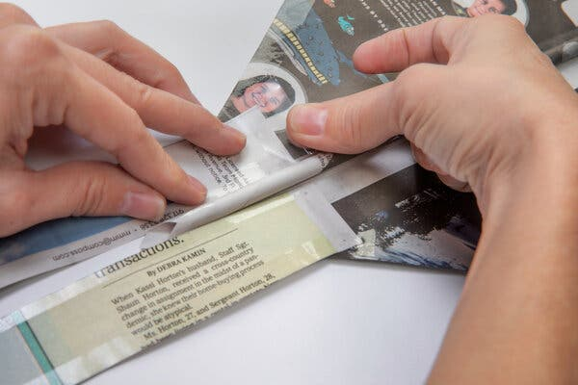
Image
Credit...Tony Cenicola/The New York Times
Step 13
Take each end of the long tail ribbon and tape to either side of the spar at the bottom of the sail. Flip the kite over and add more tape to make a really secure connection. The tail can be left as a loop, or snipped in half at the bottom to become two separate tails.
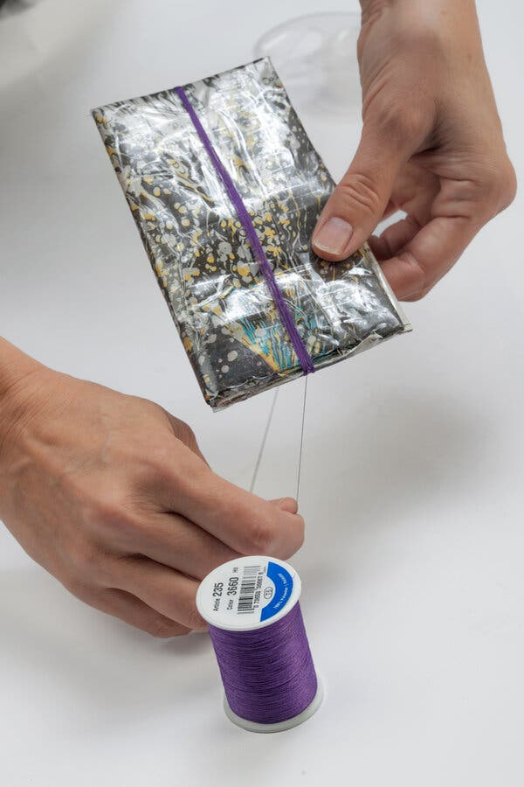
Image
Credit...Tony Cenicola/The New York Times
Step 14
Attach the free end of a roll of polyester sewing thread to a winder (you can make one out of folded up newspaper if you want) with a short strip of sticky tape. Then wind on at least 100 turns of thread. Snip the thread, ready to attach that end to the kite.
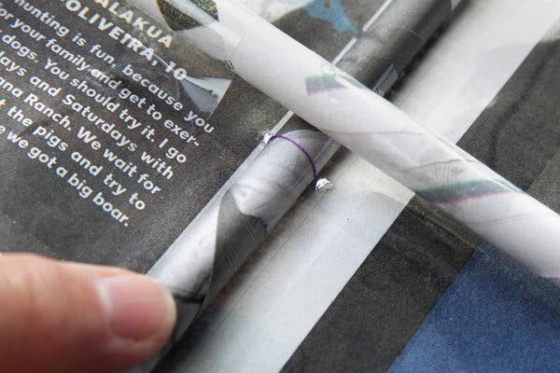
Image
Credit...Tony Cenicola/The New York Times
Step 15
Using the skewer, punch a small hole through the sail on each side of the vertical spar, just below the horizontal spar (get as close to it as possible). Poke the end of the thread through the sail, around the vertical spar and back through the other hole in the sail. Tie off using two or three half-hitch knots. Add a square of tape over the thread on the vertical spar to stop the thread shifting.

Image
Credit...Tony Cenicola/The New York Times

Now to fly!
Just to double-check, the thread comes out from one side of the kite while the spars are attached to the other side. All OK? If not, switch it around right now. To put it another way, the spars should be on the back of the flying kite, and the thread should be on the front.
This kite does not need a lot of wind to fly successfully. If you can see leaves and small twigs moving about in the trees, that’s about right. If you drop some dry leaves or dirt and can’t run or jog to keep up with it as it blows downwind, it’s too strong. Wait for lighter wind.
This kite is strong enough to fly well in winds up to 16 miles per hour but being only paper, bending the spars is a risk. At least you can make new ones in only a few minutes, if some kite surgery is needed.

